**Servlet Tutorial**

**Servlet** technology is used to create web application (resides at server side and generates dynamic web page).

**Servlet** technology is robust and scalable because of java language. Before Servlet, CGI (Common Gateway Interface) scripting language was popular as a server-side programming language. But there was many disadvantages of this technology. We have discussed these disadvantages below.

There are many interfaces and classes in the servlet API such as Servlet, GenericServlet, HttpServlet, ServletRequest, ServletResponse etc.

What is a Servlet?

Servlet can be described in many ways, depending on the context.

* Servlet is a technology i.e. used to create web application.
* Servlet is an API that provides many interfaces and classes including documentations.
* Servlet is an interface that must be implemented for creating any servlet.
* Servlet is a class that extend the capabilities of the servers and respond to the incoming request. It can respond to any type of requests.
* Servlet is a web component that is deployed on the server to create dynamic web page.

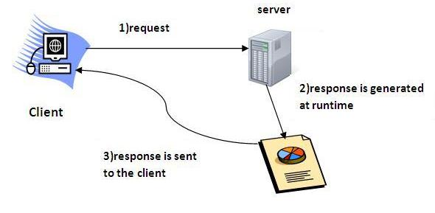

**Life Cycle of a Servlet (Servlet Life Cycle)**

The web container maintains the life cycle of a servlet instance. Let's see the life cycle of the servlet:

1. Servlet class is loaded.
2. Servlet instance is created.
3. init method is invoked.
4. service method is invoked.
5. destroy method is invoked

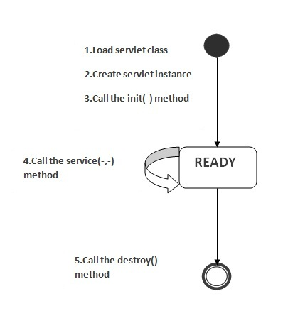

As displayed in the above diagram, there are three states of a servlet: new, ready and end. The servlet is in new state if servlet instance is created. After invoking the init() method, Servlet comes in the ready state. In the ready state, servlet performs all the tasks. When the web container invokes the destroy() method, it shifts to the end state.